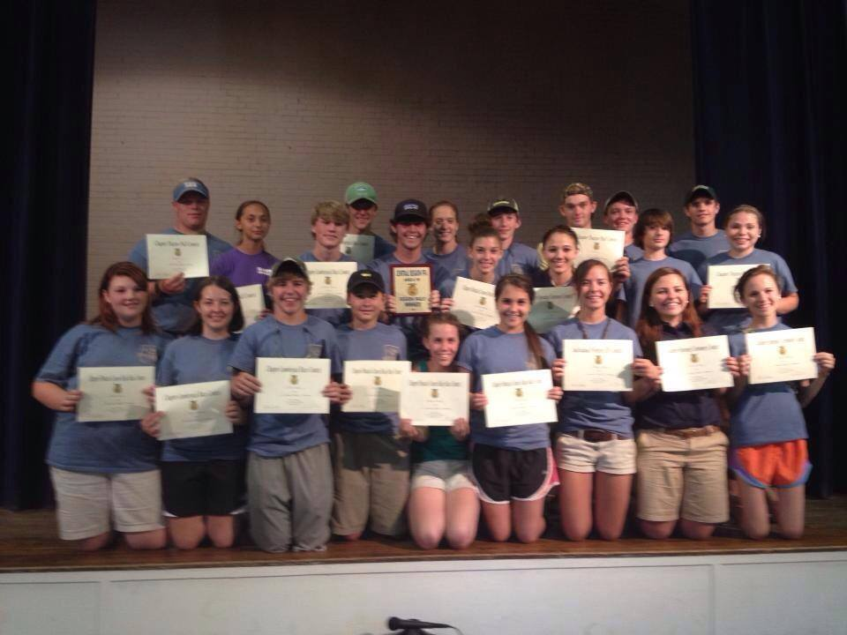

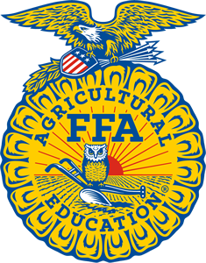
Central Region FFA

Area 4 – Monday, September 11, 2017
Area 3 - Tuesday, September 12, 2017
At Camp John Hope in Fort Valley, GA

Sling Shot Challenge
Chapter 4-man Lumberjack Race Low Ropes Obstacle Course
Chapter Officer Opening Ceremony Contest
Leadership and Team-Building Events Ag Mechanics Relay
Chapter Advisor Challenge
Bring your bathing suit & towel so you can enjoy the pool!

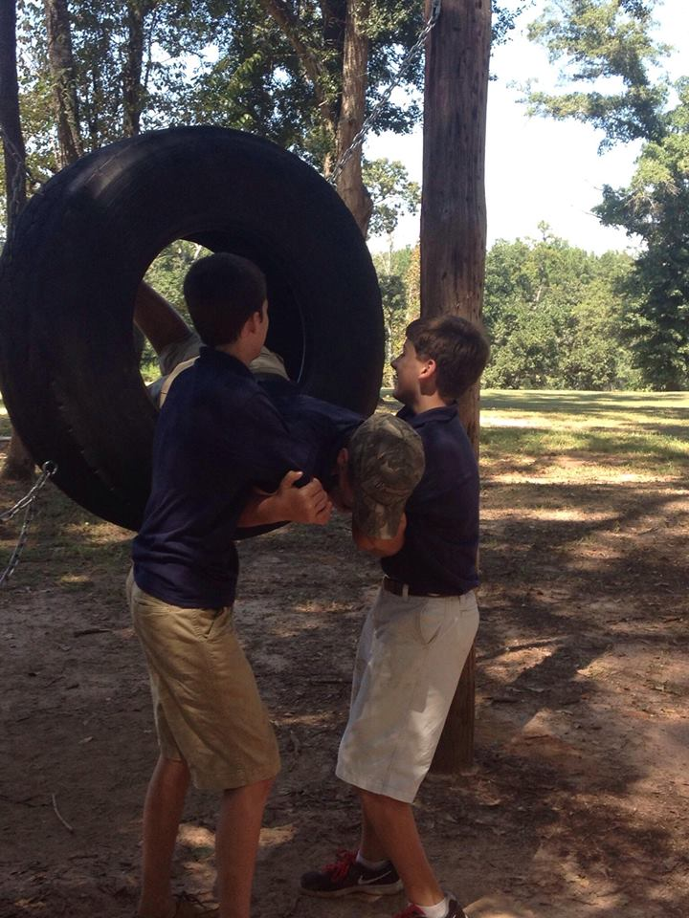

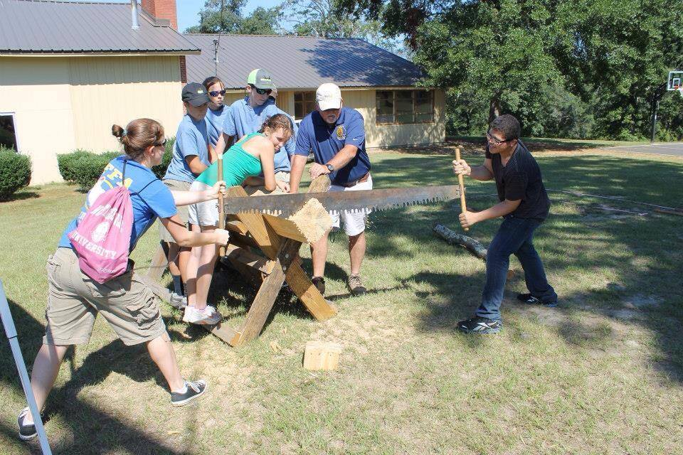
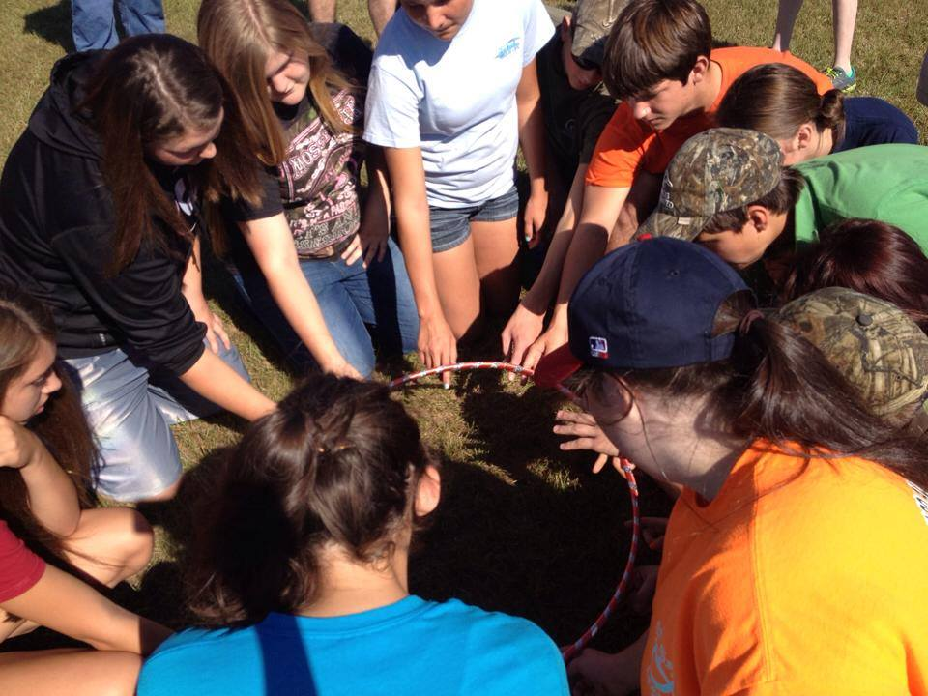
* Registration Deadline is Monday, August 28th!

