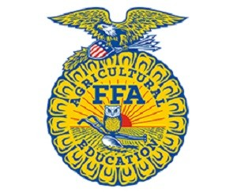
Contact:
Chris Corzine
Central Region Director
ccorzine@gaaged.org

News Release
For Immediate Release

_____(school name)________ FFA Members and Advisors Participate in
Community Service Project for Feeding American and Middle Georgia Food Bank

Perry, GA - _____(school name)____________ FFA Chapter attended the Central Region FFA Leadership Rally on September 10/11, 2018 where they worked with the Area 3 and Area 4 FFA Area Officer Teams to collect items for Feeding America and the Middle Georgia Food Bank. This community service project partnered with the organization Feeding America to compact the growing issue of hungry children in Georgia. Students were able to hear from speaker, Eliza McCall, with Second Harvest of South Georgia and learned that one in every five children in Georgia doesn’t have enough to eat. The two day leadership rally collected a total of 4,212 lbs of food for the Middle GA Community Food Bank. This equals about 3,509 meals for those in need in the Middle Georgia area. Middle Georgia Community Food Bank serves 24 counties in Middle Georgia. Through the support of over 190 Partner Agencies, or food pantries, they are able to provide nutritious supplemental food to our hungry neighbors in need, and address food insecurity that is present in our own backyards.

FFA Members, _____(student’s names)_________________, donated about _______ pounds of canned food for the food drive. ____(teacher name)_______ serves as the chapter advisor for ___(school name)_______ FFA.

Community service is an important part of an FFA chapter serving as one of the three components of the chapter’s program of activities. Not only does this project address a major need in the middle Georgia area but also gives students a chance to give back to students their own age. FFA students are required to complete a minimum number of community service hours in order to earn their State FFA degree and other FFA awards.
FFA makes a positive difference in the lives of students by developing their potential for premier leadership, personal growth and career success through agricultural education. FFA membership today is comprised of 649,355 student members in grades sixth through 12 who belong to one of 7,859 local FFA chapters throughout the United States, Puerto Rico and the U.S. Virgin Islands.
###

